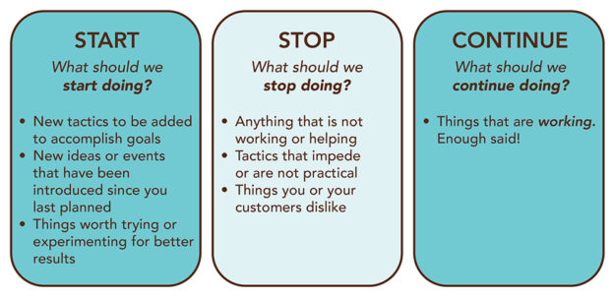

START  What should we  start doing? | STOP  What should we  stop doing? | CONTINUE  What should we continue doing?

Goal 1 – Student achievement
LCAP Action | LCAP  Sub - Action | Recommendation  (Stop – Start – Continue) | Rationale

Goal 2 – Equitable Learning Environments
LCAP Action | LCAP  Sub - Action | Recommendation  (Stop – Start – Continue) | Rationale

Goal 3 –Equitable Learning Environments
LCAP Action | LCAP  Sub - Action | Recommendation  (Stop – Start – Continue) | Rationale

Goal 4 – Differentiated Assistance
LCAP Action | LCAP  Sub - Action | Recommendation  (Stop – Start – Continue) | Rationale

